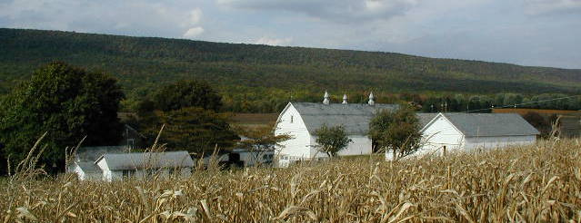

**Farmland Preservation News**

Lehigh County

OSWALD FARM. LYNN TOWNSHIP

FALL 2017

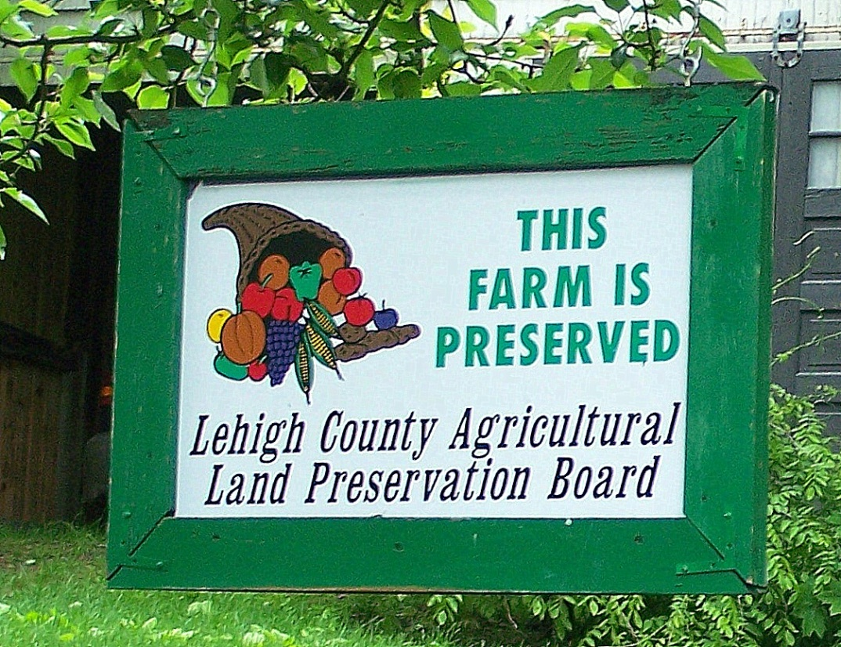

**Preserved Farmland by Township**

**As of Aug 22, 2017**

|  |  |  |
| --- | --- | --- |
| **Township** | **# of Farms** | **Acreage** |
| Lynn | 91 | 7,698.9 |
| Weisenberg | 48 | 4,181.2 |
| Heidelberg | 45 | 3,309 |
| Lower Milford | 41 | 3037.1 |
| Upper Macungie | 9 | 781.5 |
| Upper Milford | 18 | 960.1 |
| Lowhill | 6 | 562.1 |
| Lower Macungie | 9 | 563.59 |
| Washington | 8 | 611.42 |
| Upper Saucon | 8 | 341.5 |
| North Whitehall | 2 | 238.9 |
| South Whitehall | 1 | 70.2 |
| Other * |  | 132.54 |
| **Totals** | **286** | **22,488** |

* Preserved farmland that extends into neighboring counties.

**2019 Application Deadline:** **July 1, 2018**

Call Diane Matthews-Gehringer at 610-391-9583 x 14 for an application form. Applications can be mailed or dropped off at:

Lehigh County Farmland Preservation Program

Lehigh County Agricultural Center, Suite 107

4184 Dorney Park Road

Allentown, PA 18104

**22,488 Acres of Farmland Preserved**

Lehigh County is in its 27th year of preserving farmland with perpetual agricultural conservation easements. As of Aug 22, 2017 Lehigh County has preserved just under **22,488 acres** of farmland. And over 20 farms are in the process of preservation from the 2017 deadline.

This would not have been possible without the long term commitment of the County of Lehigh, the Commonwealth of Pennsylvania, local municipalities, and the many conservation-minded landowners who have made the choice to permanently protect their farmland for the future.

Lehigh County has allocated **$2,000,000** in matching funds for the program in 2017, 2018, and 2019. The Commonwealth allocated **$2,575,475** to Lehigh County in 2017 for farmland preservation. There is a total of **$4,575,475** available for easement purchases in 2017.

**Have a Question?**

**Need Information on the Farmland Preservation Program?**

Call our office at 610-391-9583 x 14, OR

Email: [Dianematthews-gehringer@lehighcounty.org](mailto:Dianematthews-gehringer@lehighcounty.org)

WENTZ FARM, HEIDELBERG TOWNSHIP

**Biennial Inspections**

Some of you may be wondering why the farmland preservation office staff did not visit your farm last year. Act 19, amending Pennsylvania's Agricultural Area Security Law (Act 43 of 1981), changed the regulatory requirement to do annual farmland preservation inspections. The Sterling Raber Agricultural Land Preservation Board voted to adopt this new rule and **farms are inspected every other year** instead of yearly. Another change is the office staff will not be meeting with you in person during the inspection, unless you wish to make an appointment. Farms that have received federal funding for farmland preservation will still be inspected annually because of federal rules.

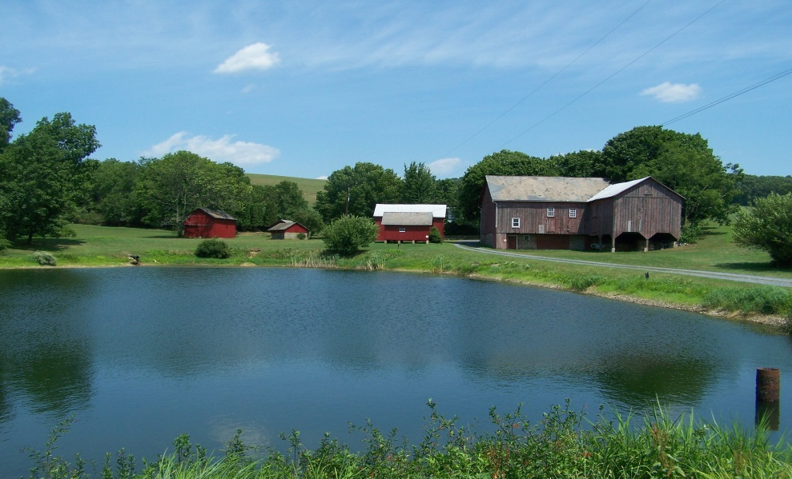

**Subdivision Guidelines**

Since the start of Lehigh County Farmland Preservation there have been 3 revisions of the Subdivision Guidelines. Each Deed of Easement **must follow** the guidelines that were current at the time of preservation. If you are considering Subdivision, you should contact the office for clarification on how the guidelines affect you, or if subdivision is even permitted for your farm.

**Conservation Plan Requirements**

The Deed of Agricultural Conservation Easement requires that all farming be conducted in accordance with an approved conservation plan. Conservation plans must include the following components: a conservation practice installation schedule, a maintenance program and a nutrient management component**. Many of the conservation plans on file for preserved properties are out of date, because of new owners, new operators, and time.** You may need to set up an appointment to review and updateyour conservation plan. **Please contact Diane Matthews-Gehringer to discuss if you need a new Conservation Plan. 610-391-9583 X 14** [Dianematthewsgehringer@lehighcounty.org](mailto:Dianematthewsgehringer@lehighcounty.org)

**Farm Transfer/Sale Responsibilities**

**Are you planning to sell your farm?** Do you want to transfer the farm to a son or daughter? Or perhaps you are planning to create a family trust or partnership. These are all considered ownership changes that **require a new property deed**. State law requires that a copy of the Deed of Agricultural Conservation Easement be included in the new deed**. It is the responsibility of the seller to furnish us with:**

1. Name and address of new owner.

2. Price per acre received by the seller.

3. Ensure that the new deed is prepared properly and recorded.

4. If the farm was subdivided, which portion receives the right to construct the one additional residence allowed by law? This must be clearly indicated in the new deed.

We can provide a deed preparation instruction sheet to your deed preparer and we will gladly review a draft deed prior to signing.

**2018 Has Record Applicants!**

2018 has proven to be a record year for Farmland Preservation applications.

With the increase in funding and municipal outreach, **28 farms** have been added to the ranked list for consideration of preservation.

Re-ranking of all the remaining farms not in process for 2016/17 still needs to be completed, but it could mean upwards of 84 farms now on the waiting list for 2018.