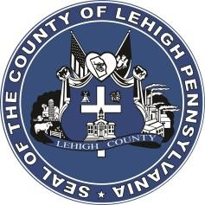

LEHIGH COUNTY

Public Information Office

Government Center

|
17
South
Seventh Street

Allentown, PA

18101
-
2401

Phone:
610
-
782
-
300
2

|
Fax: 610
-
8
71
-
275
5

Press Release

FOR IMMEDIATE RELEASE: CONTACT: Adrianna Calderon
January 26th, 2024 610-782-3002

Lehigh County Announces Pardon Project

LEHIGH COUNTY, PA- The Pardon Project of Lehigh County was created to help members of the community who were convicted of a non-violent crime, completed their sentence for at least five years, and their past is holding them back from pursing their full potential.

A pardon is total forgiveness by the state and a powerful tool for people who deserve a second chance. In Pennsylvania, the pardon process is free and more accessible than ever. Under Lehigh County Executive Phil Armstrong’s Administration, there will now be a Pardon Coordinator embedded in the Public Defender’s Office.

Guidelines to qualify for the Lehigh County Pardon Project are the same financial guidelines used to qualify residents for legal representation through the Lehigh County Public Defender’s Office. In addition, there are guidelines regarding which cases the Pardon Project will accept. Further information regarding the Lehigh County Pardon Project can be found at https://pardonmepa.org/lehigh/.

The potential benefits of a pardon and expungement are significant and can create a range of opportunities that may not have been available otherwise. Lehigh County wants to help its residents realize this opportunity.

###

