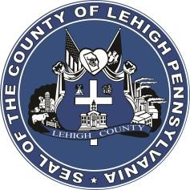

LEHIGH COUNTY

Public Information Office

Government Center

|
17
South
Seventh Street

Allentown, PA

18101
-
2401

Phone:
610
-
782
-
300
2

|
Fax: 610
-
8
71
-
275
5

Press Release

FOR IMMEDIATE RELEASE: CONTACT: Adrianna Calderon
August 31, 2023 610-782-3002

Lehigh County to Host Household Hazardous Waste Event for Residents

LEHIGH COUNTY, PA- Lehigh County will be holding a household hazardous waste (HHW) collection event on September 16th, 2023 in the Coca-Cola stadium parking lot. This county-wide event is for residential use only, no commercial entities will be accepted.

There is a mandatory pre-registration form residents must fill out if they wish to participate in the collection event. The pre-registration process helps Lehigh County verify residency to ensure taxpayer’s dollars are being spent on its residents.

The link for pre-registration is available on the home page of Lehigh County’s website, at www.lehighcounty.org. All pertinent information, including acceptable materials, directions on safely transporting materials, and appointment times will be included on the website.

