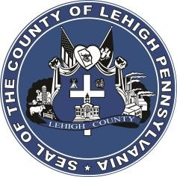

LEHIGH COUNTY

Public Information Office

Government Center

|
17
South
Seventh Street

Allentown, PA

18101
-
2401

Phone:
610
-
782
-
300
2

|
Fax: 610
-
8
71
-
275
5

Press Release

FOR IMMEDIATE RELEASE: CONTACT: Adrianna Calderon February 9, 2023 AdriannaCalderon@lehighcounty.org
610-782-3002

Lehigh and Northampton Counties become the Nation’s First Dual-County Community to receive Certification in the World Health Organization/AARP Network of Age-Friendly States and Communities

ALLENTOWN, PA- Lehigh and Northampton counties became the nation’s first dual-county to receive certification. United way and Age-Friendly Lehigh Valley, led by Carmen Bell, have worked directly with AARP Pennsylvania to achieve this certification since 2018. This connection ensures that there is equitable and inclusive awareness and access to these various resources for all seniors.
County Executive Phil Armstrong said at the Board of Commissioners meeting on February 8th, 2023
“I think it’s very important that we have a community that recognizes the needs of the senior population. Not only in just medical and housing, but how to get to those things, that our transportation meets their needs. Walkability, benches, little things like that came to light from all the meetings I attended. It was really eye opening. I’m very proud of Lehigh County to have been part of this right from the very beginning. It’s nice that United Way and AARP is recognizing for it, but as we have found out, we have miles to go yet too, this isn’t saying that we’re all done. But it is saying that we value our senior population, and we’re going to work as a board and Executive Branch to make sure we continue to improve.”
###

